P170

Hanes
Comfortblend
Hooded Pullover

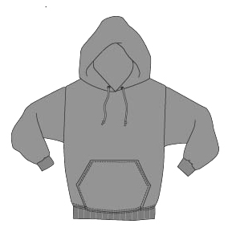

Descriptions
*50/50 poly cotton, 7.8 ounce Printpro fleece
*Double-ply hood with grommet
*Matching drawcord
*Muff pocket
*Set in sleeves
*Embroidery or screenprinting okay

Finished Garment Measurements

Size | S | M | L | XL | 2XL | 3XL | 4XL
Width | 20 | 22 | 24 | 26 | 28 | 30 | 32
Length | 26½ | 27 ½ | 28 ½ | 29 ½ | 30 | 30 ½ | 31
Sleeve Length CB | 34 1/8 | 35 3/8 | 36 | 36 3/4 | 37 1/2 | 38 1/4 | 39

